Framework and Delivery Plan Purpose
The Cycling Framework for Active Travel sets out our strategic priorities and shared actions to maximise cycling’s contribution in realising the Scottish Government’s long term Vision for Active Travel in Scotland: That Scotland’s communities are shaped around people, with walking and cycling the most popular choice for everyday short journeys.
The top priority for the achievement of our vision is for the delivery of more dedicated, high quality, safe cycling infrastructure, effectively resourced, where fair access is ensured and uptake is supported with training and education.
1. Do you agree with the above statement of strategic priorities for driving the development of cycling for transport in Scotland?
Please select only one item
Yes
No
Comment:

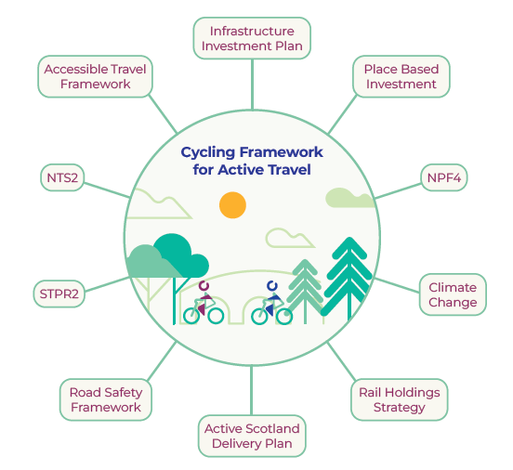
2. The diagram above sets out how the Cycling Framework is aligned to the wider policy context. Do you agree that this captures the key policy linkages and/or should any policy areas be added or removed?
Please select only one item
Yes
No
Comment:

3. Six strategic themes have been identified based on stakeholder feedback. These are: Safe Cycling Infrastructure; Effective Resourcing; Fair Access; Training and Education; Network Planning; Monitoring. These themes illustrate the overarching approach for cycling for transport in Scotland. Do you agree with these strategic themes as priority areas for action in this framwork?
Please select only one item
Yes
No
Comment:

Delivery Plan – Safe Cycling Infrastructure
4. Do you have any comments on the substance of the delivery plan actions in this section?
Comment:

5. Do you have any comments on the agencies identified to lead and support these actions?
Comment:

6. Do you have any other comments on this section of the delivery plan?
Comment:

Delivery Plan – Effective Resourcing
7. Do you have any comments on the substance of the delivery plan actions in this section?
Comment:

8. Do you have any comments on the agencies identified to lead and support these actions?
Comment:

9. Do you have any other comments on this section of the delivery plan?
Comment:

Delivery Plan – Fair Access
10. Do you have any comments on the substance of the delivery plan actions in this section?
Comment:

11. Do you have any comments on the agencies identified to lead and support these actions?
Comment:

12. Do you have any other comments on this section of the delivery plan?
Comment:

Delivery Plan – Training and Education
13. Do you have any comments on the substance of the delivery plan actions in this section?
Comment:

14. Do you have any comments on the agencies identified to lead and support these actions?
Comment:

15. Do you have any other comments on this section of the delivery plan?
Comment:

Delivery Plan – Network Planning
16. Do you have any comments on the substance of the delivery plan actions in this section?
Comment:

17. Do you have any comments on the agencies identified to lead and support these actions?
Comment:

18. Do you have any other comments on this section of the delivery plan?
Comment:

Delivery Plan – Monitoring
19. Do you have any comments on the substance of the delivery plan actions in this section?
Comment:

20. Do you have any comments on the agencies identified to lead and support these actions?
Comment:

21. Do you have any other comments on this section of the delivery plan?
Comment:

Active Travel Transformation Project
In the ‘Bute House Agreement’ between the Scottish National Party and the Scottish Green Party in 2021, it was agreed that at least £320m or 10% of the total transport budget will be allocated to Active Travel (AT) by 2024/25. There is consensus that existing AT delivery models will not be scalable, nor in many cases suitable to meet the ambition of this new budget.
An Active Travel Transformation Project (ATTP) has been set up to assess the current delivery model and inform and implement a new delivery model for the future of AT. The primary objective of the ATTP is to maximise the opportunities in AT delivery in the short-term (2022/23) and medium term (2023/24-2024/25), to deliver the most effective and efficient achievement of AT outcomes.
Working closely with AT delivery partners, the ATTP is being delivered in two phases. Phase one focuses on evaluation and evidence gathering. This phase aims to assess the existing active travel delivery model by identifying constraints and opportunities. Phase two will use this evidence to develop and prioritise proposals for changing the delivery model.
The ATTP will culminate in December 2022 with a report to the Minister for Active Travel which will provide evidenced proposals for holistic changes to AT delivery in Scotland.
As part of the ATTP we are considering different models of incentivisation, evaluation and monitoring for local authorities.
To what extent do you agree with the following statements:
22. For large infrastructure projects, conditions of funding should be delivery on agreed targets for: timescales, expenditure and meeting project objectives.
Please select only one item
Strongly Agree
Agree
Neither Agree or Disagree
Disagree
Strongly Disagree
Comment:

23. In order to ensure maximum value for money and impact, active travel funding in the short term should be prioritised for those local authorities with the greatest capacity to deliver, with capacity building support offered to those with the least.
Please select only one item
Strongly Agree
Agree
Neither Agree or Disagree
Disagree
Strongly Disagree
Comment:

24. Future funding for active travel infrastructure should include a mechanism for re-distributing investment from local authorities unable to deliver to agreed standards and timescales.
Please select only one item
Strongly Agree
Agree
Neither Agree or Disagree
Disagree
Strongly Disagree
Comment:

Impact Assessments
As part of the development of this policy framework, and to comply with our statutory obligations, a number of impact assessments have been carried out. These impact assessments are currently in the draft - or pre-screening - stage and are available to read alongside the framework and delivery plan.
The impact assessments that have been carried out are: Social and Equalities Impact Assessment (SEQIA), Business Regulatory Impact Assessment (BRIA), and Island Communities Impact Assessment (ICIA).
In order to inform the next phase of the development of the framework and delivery plan we welcome your comments on the draft impact assessments.
25. Do you have any comments on the draft Social and Equalities Impact Assessment?
Comment:

26. Do you have any comments on the draft Business Regulatory Impact Assessment?
Comment:

27. Do you have any comments on the draft Island Communities Impact Assessment?
Comment:

About you
Please indicate how you wish your response to be handled and, in particular, whether you are content for your response to published. If you ask for your response not to be published, we will still take account of your views in our analysis but we will not publish your response, quote anything that you have said or list your name. We will regard your response as confidential, and we will treat it accordingly.
To find out how we handle your personal data, please see our privacy policy. By clicking submit you agree to our privacy policy.
What is your name?
What is your email address? (Required)
Are you responding as an individual or an organisation? (Required)
Please select only one item
Individual
Organisation
What is your organisation?
The Scottish Government would like your permission to publish your consultation response. Please indicate your publishing preference: (Required)
Please select only one item
Publish response with name
Publish response only (without name)
Do not publish response
Information for organisations only:
The option 'Publish response only (without name)' refers only to your name, not your organisation’s name. If this option is selected, the organisation name will still be published.
If you choose the option 'Do not publish response', your organisation name may still be listed as having responded to the consultation in, for example, the analysis report.
We will share your response internally with other Transport Scotland teams who may be addressing the issues you discuss. They may wish to contact you again in the future, but we require your permission to do so. Are you content for Transport Scotland to contact you again in relation to this consultation exercise? (Required)
Please select only one item
Yes
No

