The next Clyde & Hebrides Ferry Services Contract (CHFS3)

Consultation

Easy Read version

Introduction

When the Government is going to make an important change, they have to ask the people for their views first. This is called a consultation.

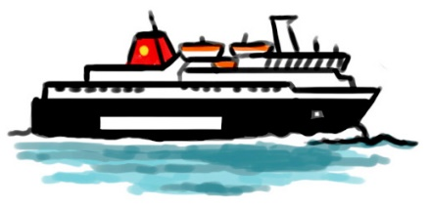
This consultation is about the new Clyde and Hebrides Ferry Services Contract (CHFS3).

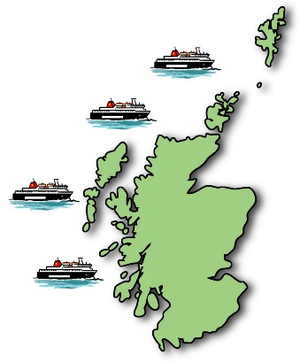

The Clyde & Hebrides Ferry Services give important links for residents, businesses, and tourists across the west coast of Scotland.

We know the service could be better. We are therefore planning to start a new contract for these ferry services which will start on 1 October 2024.

This consultation will be open from 15 December 2023 to 08 March 2024. We would like your views on our plans for the Clyde & Hebrides Ferry Services Contract.
Impact assessment
We have to look at any affects the new ferry service might have, for better or worse. This is called an impact assessment. We will look at how the service might affect businesses, children’s rights, equality, and the island communities.

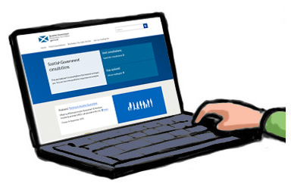
We will publish these impact assessments on the Transport Scotland website. We would like your views on these. Views can be provided to us by emailing Transport Scotland.

Reliable services

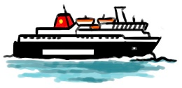
Community feedback said that ferry services need to be more reliable. It has a serious impact on business and communities when ferry services are late or cancelled.

Question 1: Do you think the system for checking ferry services is working?

Yes No

Please explain your answer in the box below:

Question 2: How should the ferry services be checked? Please tell us in the box below:

Meeting Demand

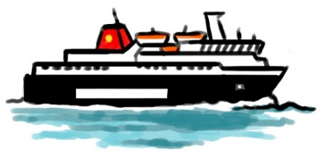
Fares have gone down in price and made Scottish Islands more accessible to everyone. But we need to find a better balance between the number of passengers and the available space on ferries.

Community feedback said there is more demand for ferry services during summer. We need to make sure enough car spaces are available at these times for people other than tourists.

Question 3: Do you have any ideas for reducing demand for vehicle space during busy times?

Yes No

If yes, what are your ideas? Please tell us in the box below:

Question 4: To reduce the number of cars on ferries, would you be willing to travel to and from a port using public transport, walking, wheeling or cycling?

Yes No

If no, please explain your answer in the box below:

Question 5: Should ferries keep spaces on busy routes for the use of island residents and workers who need to travel at short notice?

Yes No

If no, please explain your answer in the box below:

Involving the Community
Communities want more communication with ferry operators. This would allow them to give feedback which would make ferry services better.

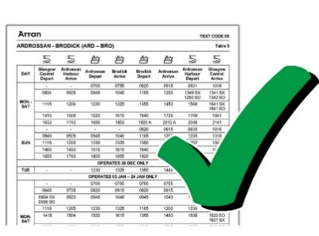

Community feedback said that ferry services need to be properly timetabled to meet the needs of different users.

Question 6: How could communities be more involved in decisions about ferry services? Please give us your views in the box below:

Question 7: Does the Ferries Community Board properly represent island communities? The Board is made up of community members to give its views to CalMac Ferries.

Yes No

If no, please explain your answer in the box below:

Question 8: Does the Ferries Community Board take your interests into account for the next ferry contract?

Yes No

If no, please explain your answer in the box below:

Question 9: Should communities be more involved in setting timetables?

Yes No

Please explain your answer in the box below:

Impact on the Environment

We are making good progress towards a net zero future. Net zero means we take as much harmful gas out of the air as we put into it.

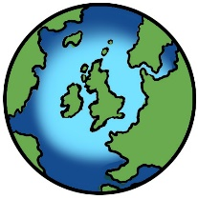
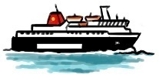
Environmentally friendly ferry engines are still being developed. We need to think of other ways to reduce the impact of ferries on the environment.

Question 10: How can ferries be more environmentally friendly? Please give us your views in the box below:

Question 11: Would you be happy to use your car less when travelling by ferry?

Yes No

If no, please explain your answer in the box below:

Connected travel
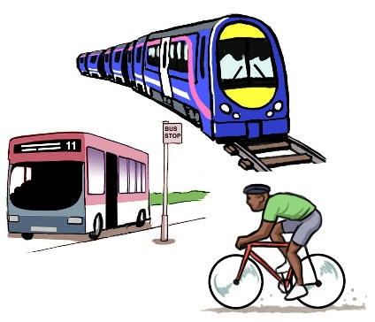
We want to look at ways to connect ferry travel with other travel like trains and buses. We also want to include more options for environmentally friendly travel.

Question 12: How do you think we could improve connections between ferries and public transport by rail and bus? Please give us your views in the box below:

Accessibility

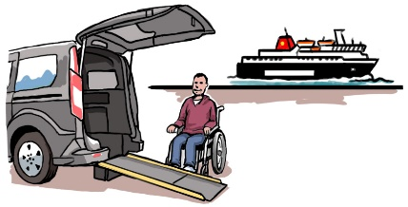
Community feedback said that some groups face challenges when accessing and using ferry services.

Question 13: How do you think we could make ferry services more accessible? Please tell us in the box below:

Freight services
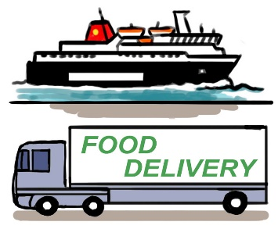
Community feedback told us that bookings for freight vehicles (lorries and vans) can mean there is less space for other vehicles on ferries.

Question 14: How could ferry services and businesses improve planning for freight vehicles? Please give us your views in the box below:

Reviewing services

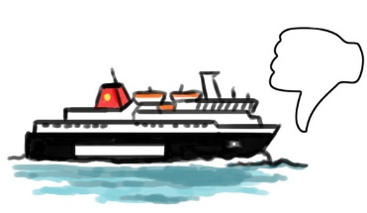
Communities want a better system for reporting problems with ferry services. They say that the true passenger experience should be included in ferry service reports.

Question 15: Would you like to give feedback to improve ferry services?

Yes No

If yes, how often should this happen and how should it be done? Please tell us in the box below:

Next Steps

Once the consultation period has ended, we will look at people’s views and give a report to Transport Scotland. They will then take this in mind when making the new ferry contract.

All consultation responses will be made public, although personal details will be kept private. If you do not want your comments to be made publicly available, please tick the box at the end of the consultation.

Thank you for taking part in this important process.

Respondent information form

This form must be completed and returned with your response.
To find out what we do with your personal data, please see our Privacy Policy

Are you responding as an individual or an organisation?
Individual
Organisation

Full name or organisation’s name:

Phone number:

Address:

Postcode:

Email:

Are you responding as a:
A resident of the Islands including Peninsulas
A resident of the Scottish Mainland
A visitor or tourist
A business (Island and Scottish mainland)

Please tell us where you live:

Why do you mainly use ferry network services?
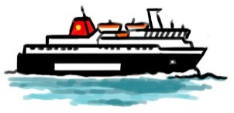
For Business
For Work/Education
For Personal/Leisure
All of the above
Other

How often do you use ferry services?

5-7 times a week
2-4 times a week
Once a week
Once every other week
Once a month
Occasionally
Seasonal (Summer Period)
Other

Are you:

Under 16
16 to 18
19 to 21
22 to 34
35 to 44
45 to 54
55 to 64
65 or over
Other

Do you have a disability?
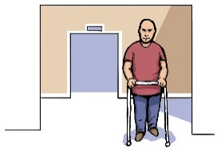
Yes
No

The Scottish Government would like to publish your consultation response. Please tell us what you want us to do:
Publish response with name
Publish response only (without name)
Do not publish response

Information for organisations:
The option 'Publish response only (without name)’ is for individuals only. If this option is selected, your organisation name will still be published.

We will share your response with other Scottish Government departments who are working on these issues. They may want to contact you in the future but we need your permission for this. Are you happy for Scottish Government to contact you again about this consultation?
Yes
No

